BookMyShow – Functional & UI Test Report
Module Name: | Movie Search, Show Selection & Ticket Booking - Functional Test Cases
Test Case ID: | bms_id_01
Tester Name: | Vaishnavi Thakor
Test Case Description: | To validate the functionality of movie discovery, city selection, showtime selection, cinema selection, seat selection, booking, offers, payment, and related user workflows on BookMyShow.
Prerequisites: | 1. Stable internet connection  2. Supported web browser  3. Valid BookMyShow website/app access  4. Available movie/show data  5. Test payment method for payment-related scenarios
Environment Information: | Webpage URL: https://in.bookmyshow.com/

Scenario ID: b1
Scenario | Open BookMyShow
Test Steps | 1. Open the BookMyShow website  2. Wait for the home page to load
Test Input | BookMyShow URL
Expected Results | BookMyShow home page loads successfully
Actual Results | BookMyShow home page loads successfully
Status | Pass
Comments | Basic navigation tested
Screenshots:


Scenario ID: b2
Scenario | Select city
Test Steps | 1. Open the city/location selector  2. Search for a city  3. Select the required city
Test Input | Ahmedabad
Expected Results | Selected city is displayed and relevant content is shown
Actual Results | Selected city is displayed and relevant content is shown
Status | Pass
Comments | City selection validation
Screenshots:
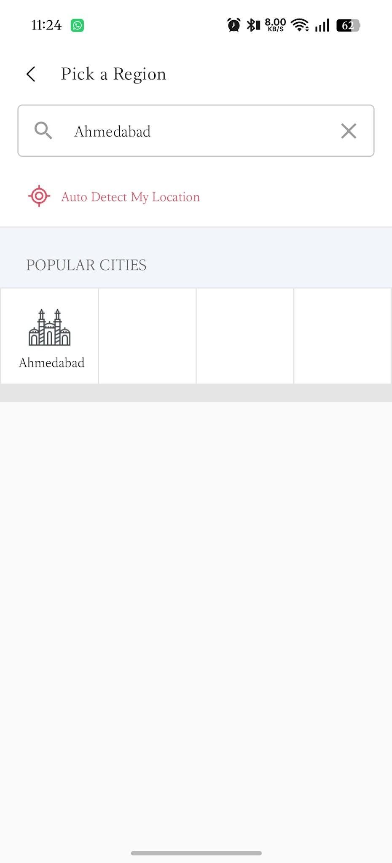

Scenario ID: b3
Scenario | Search for a movie
Test Steps | 1. Click the search field  2. Enter a movie name  3. Select the required movie from results
Test Input | A currently listed movie
Expected Results | Relevant movie search results are displayed
Actual Results | Relevant movie search results are displayed
Status | Pass
Comments | Search functionality
Screenshots:
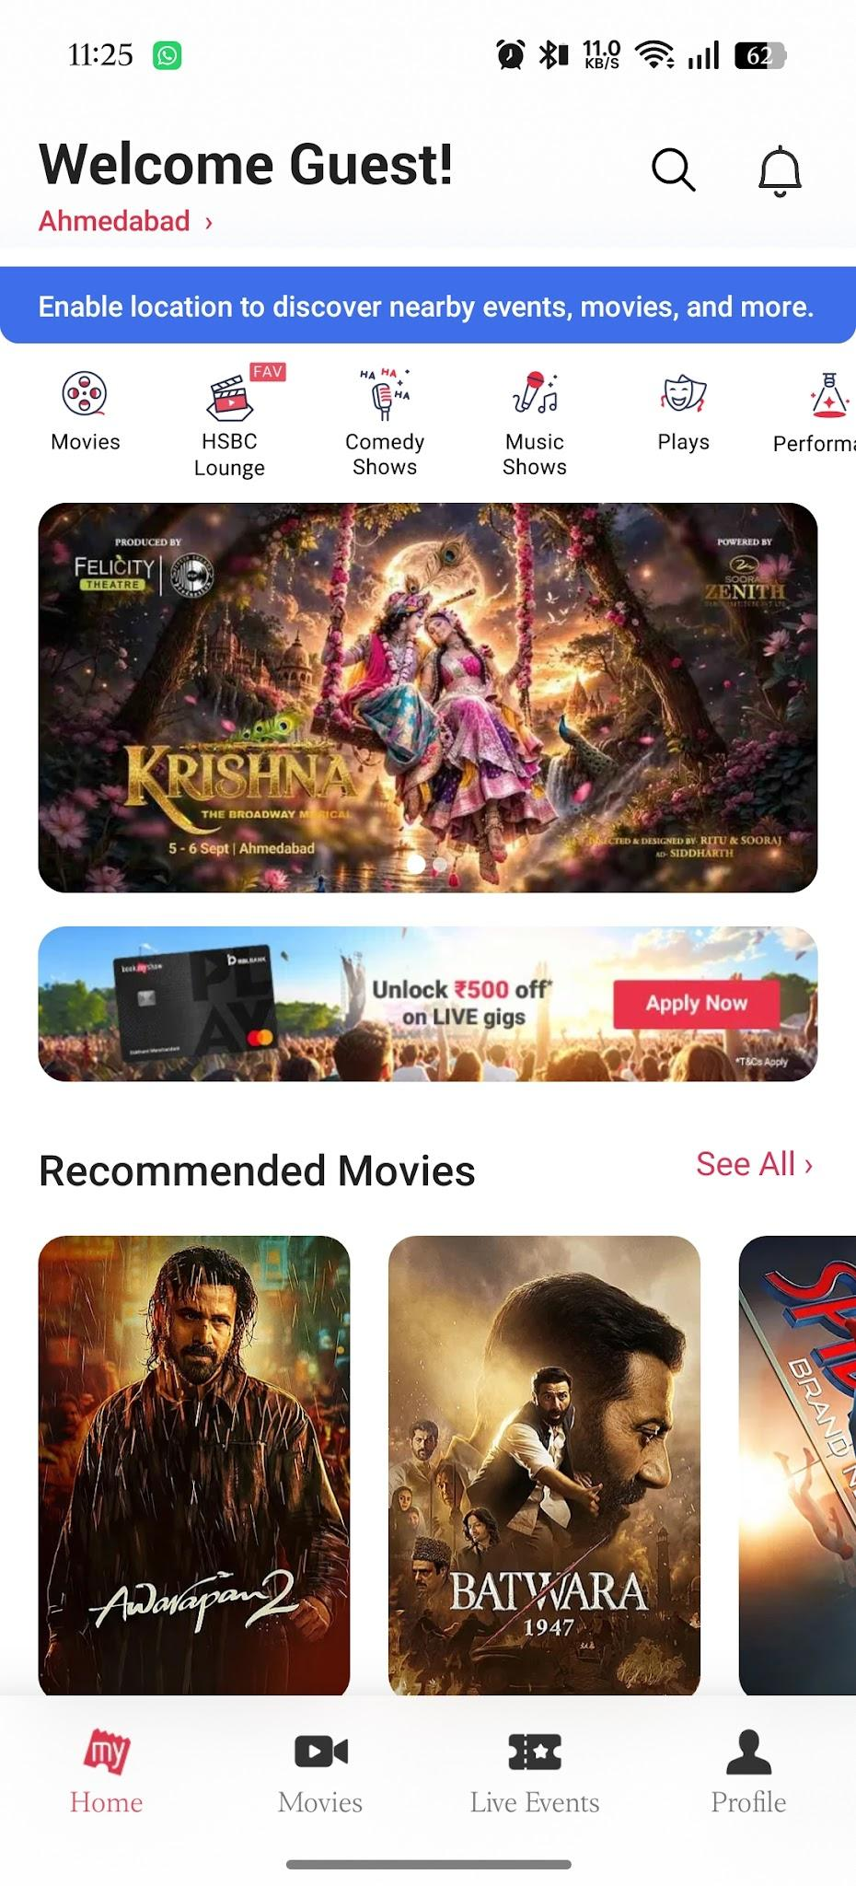
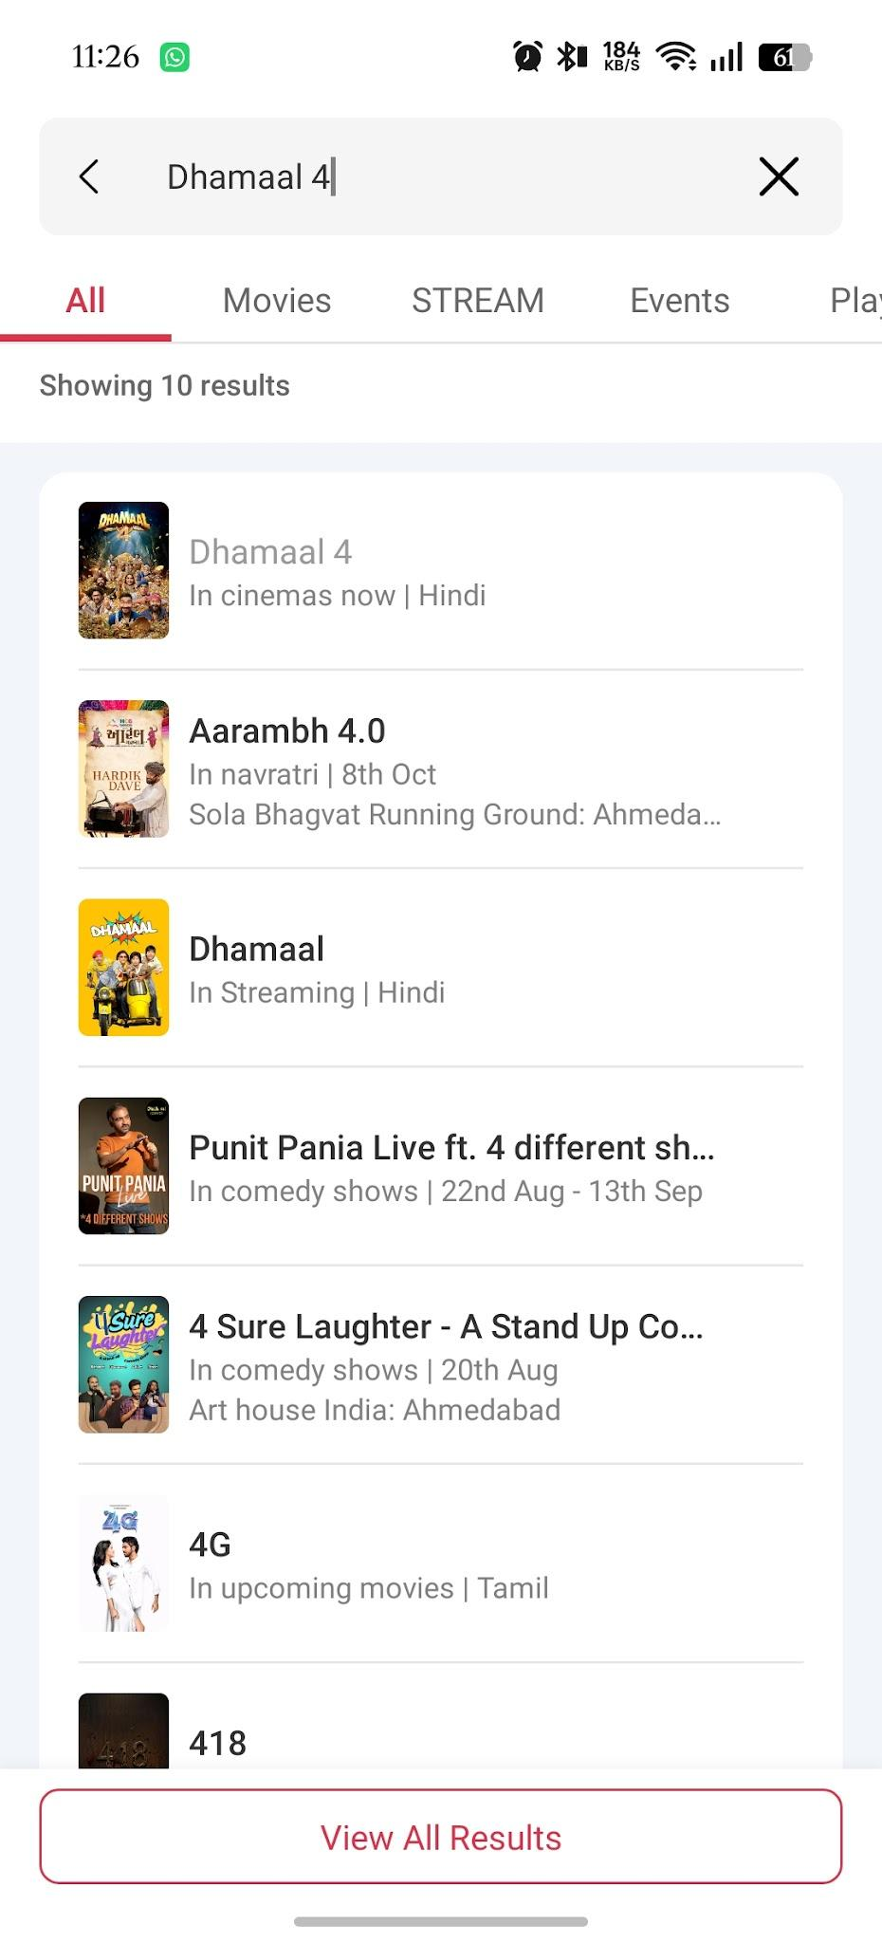

Scenario ID: b4
Scenario | View movie details
Test Steps | 1. Search for a movie  2. Click the movie title/poster
Test Input | Available movie
Expected Results | Movie details page opens with title, language, duration and other available information
Actual Results | Movie details page opens with movie information
Status | Pass
Comments | Movie information verified
Screenshots:
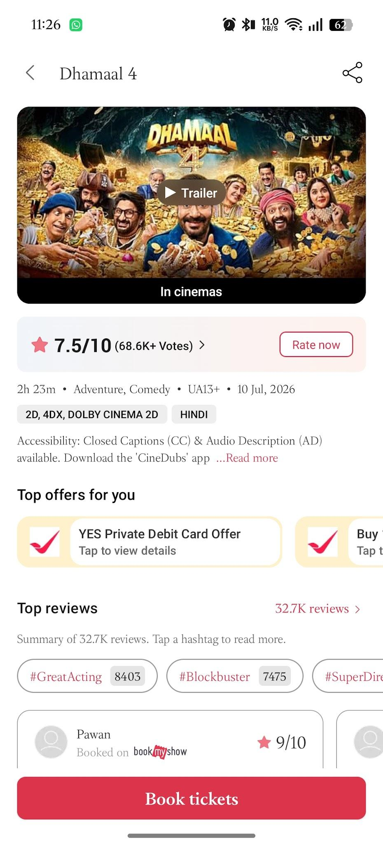

Scenario ID: b5
Scenario | Select date
Test Steps | 1. Open a movie's booking/showtime section  2. Select an available date
Test Input | Available date
Expected Results | Showtimes for the selected date are displayed
Actual Results | Showtimes for the selected date are displayed
Status | Pass
Comments | Date selection
Screenshots:
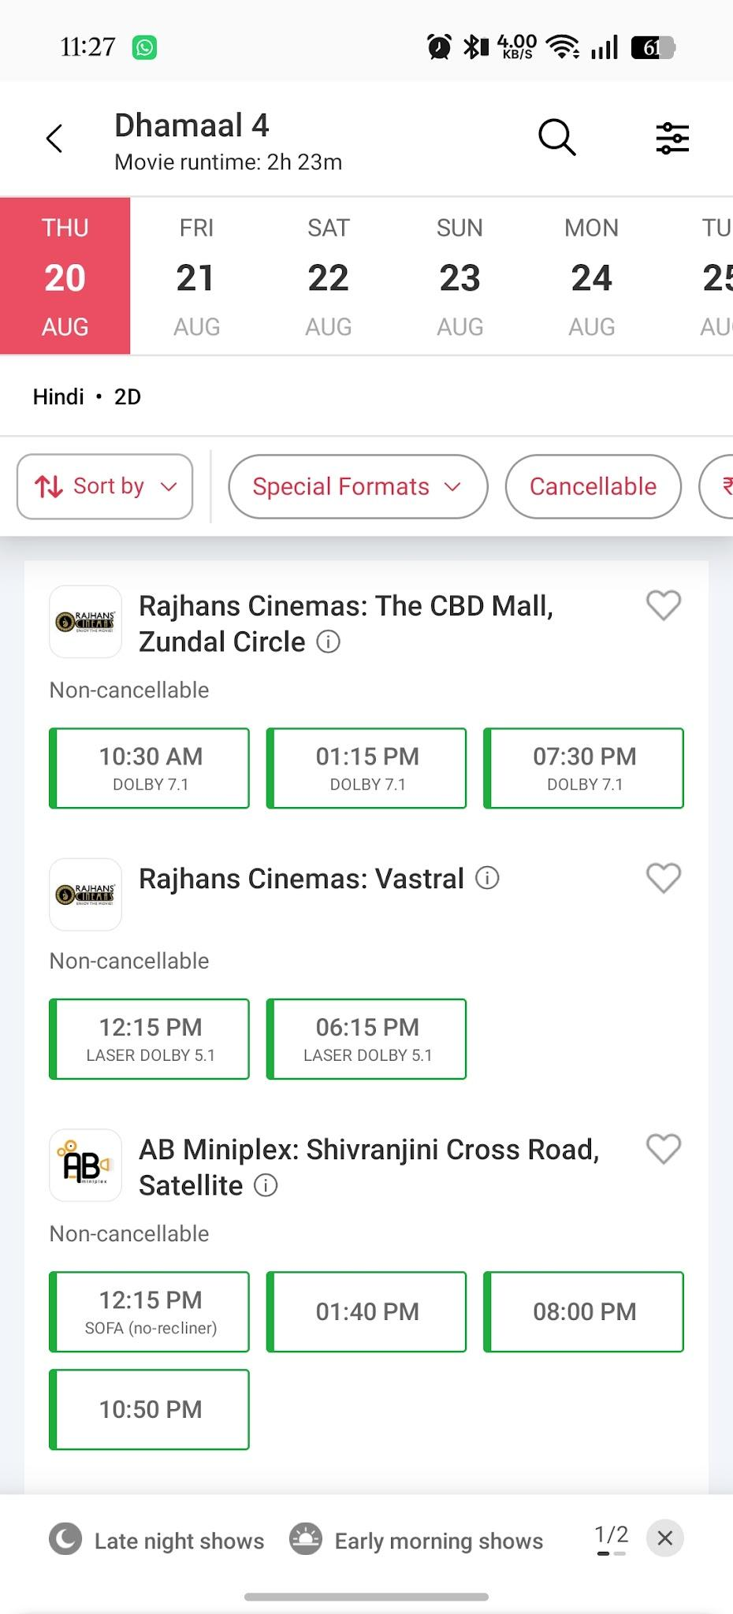

Scenario ID: b6
Scenario | Select cinema
Test Steps | 1. Open available showtimes  2. Choose a cinema
Test Input | Available cinema
Expected Results | Selected cinema and its available showtimes are displayed
Actual Results | Selected cinema and showtimes are displayed
Status | Pass
Comments | Cinema selection
Screenshots:
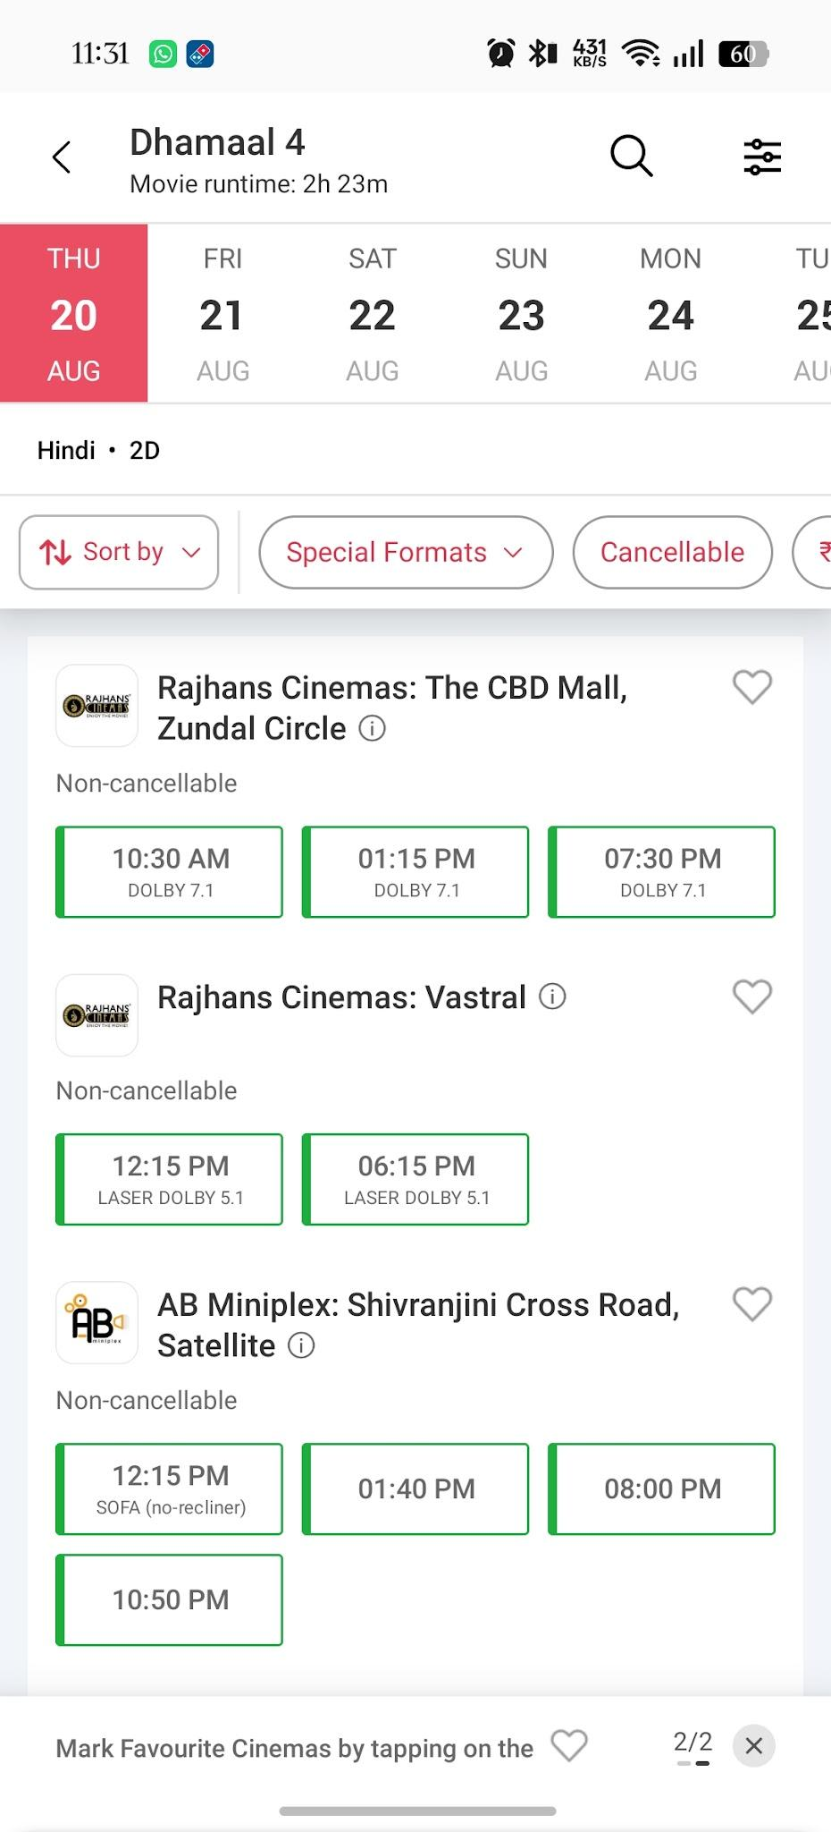
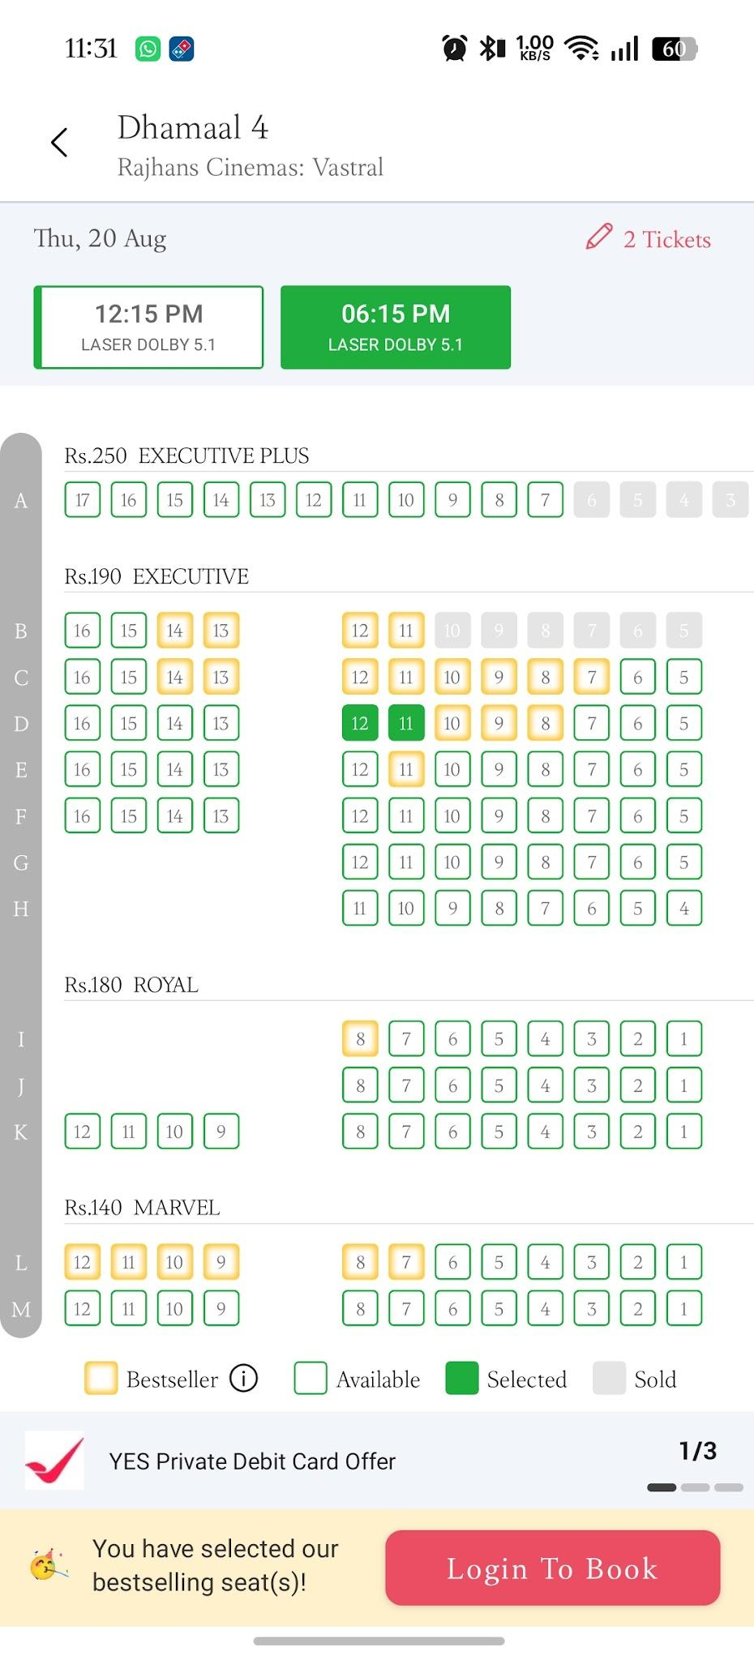

Scenario ID: b7
Scenario | Select showtime
Test Steps | 1. Choose a cinema  2. Select an available showtime
Test Input | Available showtime
Expected Results | Seat selection/booking flow opens for the selected show
Actual Results | Seat selection/booking flow opens
Status | Pass
Comments | Showtime selection
Screenshots:
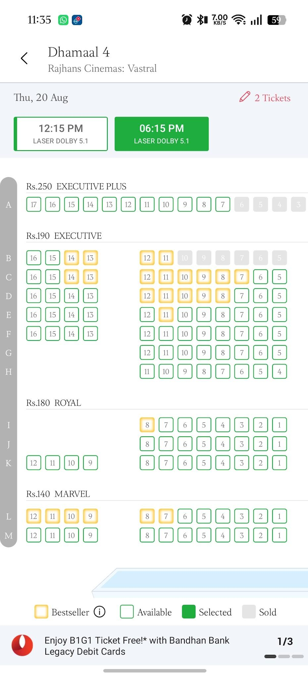

Scenario ID: b8
Scenario | Select seats
Test Steps | 1. Open seat layout  2. Select available seats  3. Continue
Test Input | Two available seats
Expected Results | Selected seats are highlighted and booking summary is updated
Actual Results | Selected seats are highlighted and summary is updated
Status | Pass
Comments | Seat selection
Screenshots:
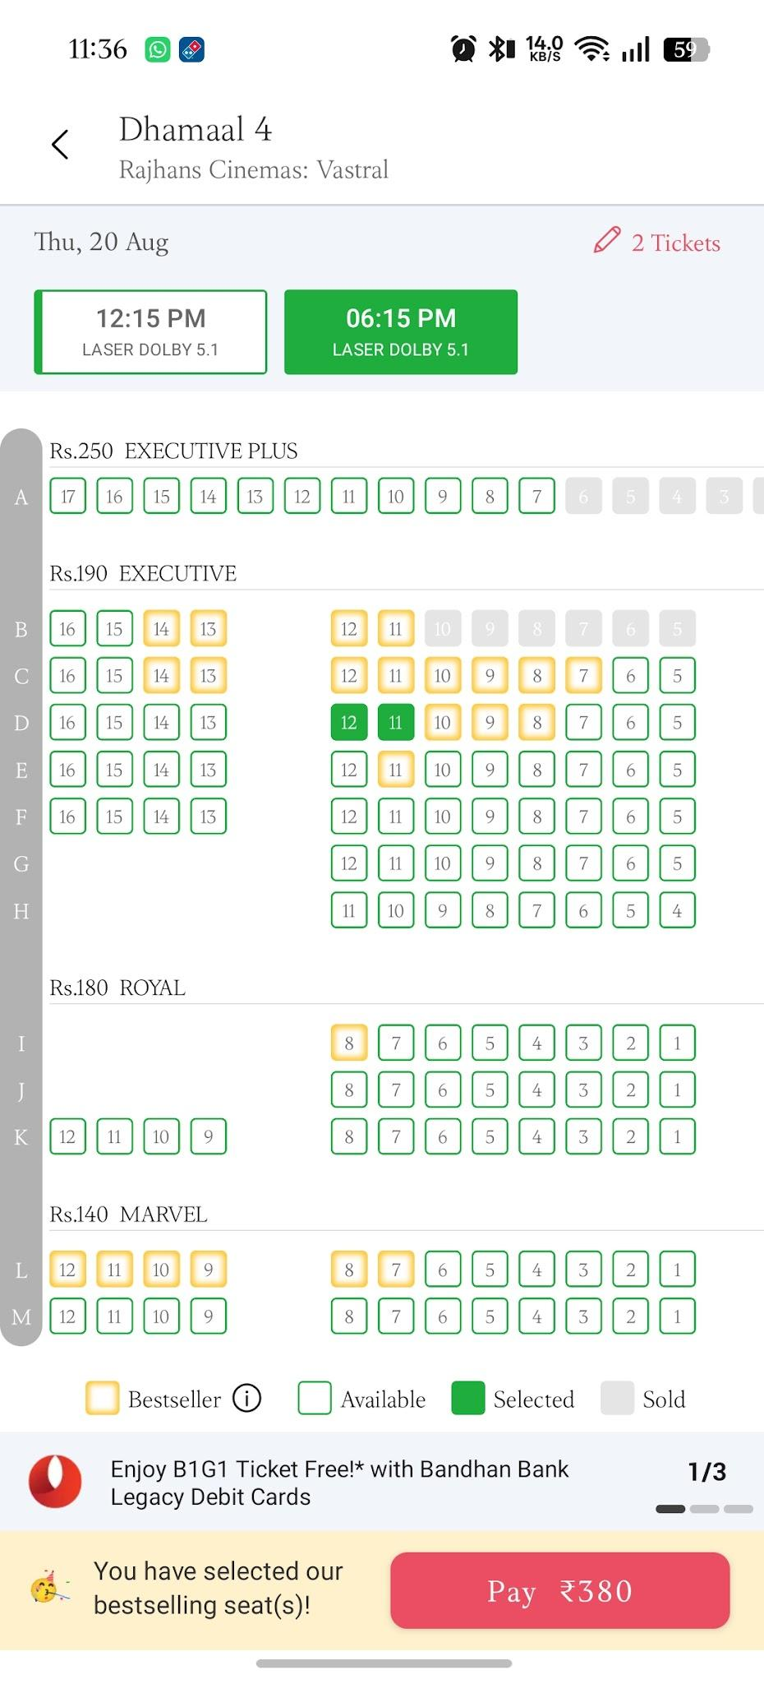

Scenario ID: b9
Scenario | Prevent unavailable seat selection
Test Steps | 1. Open seat layout  2. Identify an unavailable/booked seat  3. Attempt to select it
Test Input | Unavailable seat
Expected Results | Unavailable seat cannot be selected
Actual Results | Unavailable seat cannot be selected
Status | Pass
Comments | Negative seat-selection test
Screenshots:

Scenario ID: b10
Scenario | Verify booking summary
Test Steps | 1. Select movie, cinema, showtime and seats  2. Continue to booking summary
Test Input | Selected movie/show/2 seats
Expected Results | Summary shows correct movie, cinema, showtime, seats and payable amount
Actual Results | Summary shows selected booking details and amount
Status | Pass
Comments | Booking summary validation
Screenshots:
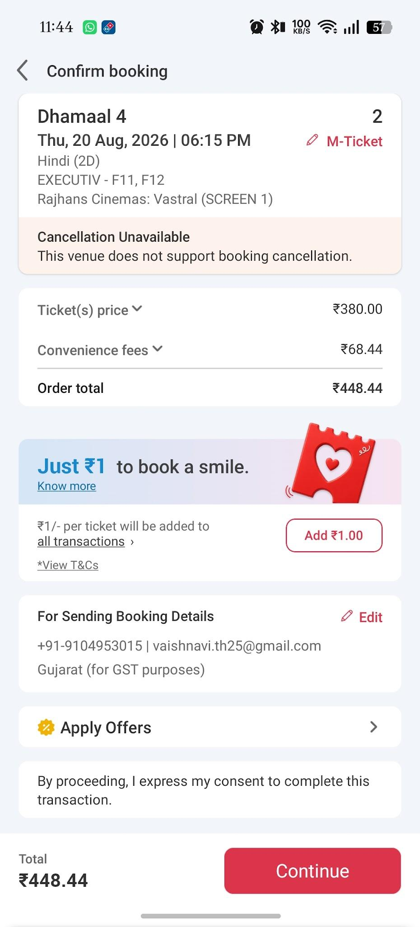

Scenario ID: b11
Scenario | Apply valid offer/coupon
Test Steps | 1. Proceed to payment/summary  2. Enter a valid applicable offer code  3. Apply
Test Input | Valid applicable offer
Expected Results | Eligible discount is applied and total amount is recalculated
Actual Results | Applicable discount is reflected and total is recalculated
Status | Pass
Comments | Offer validation
Screenshots:
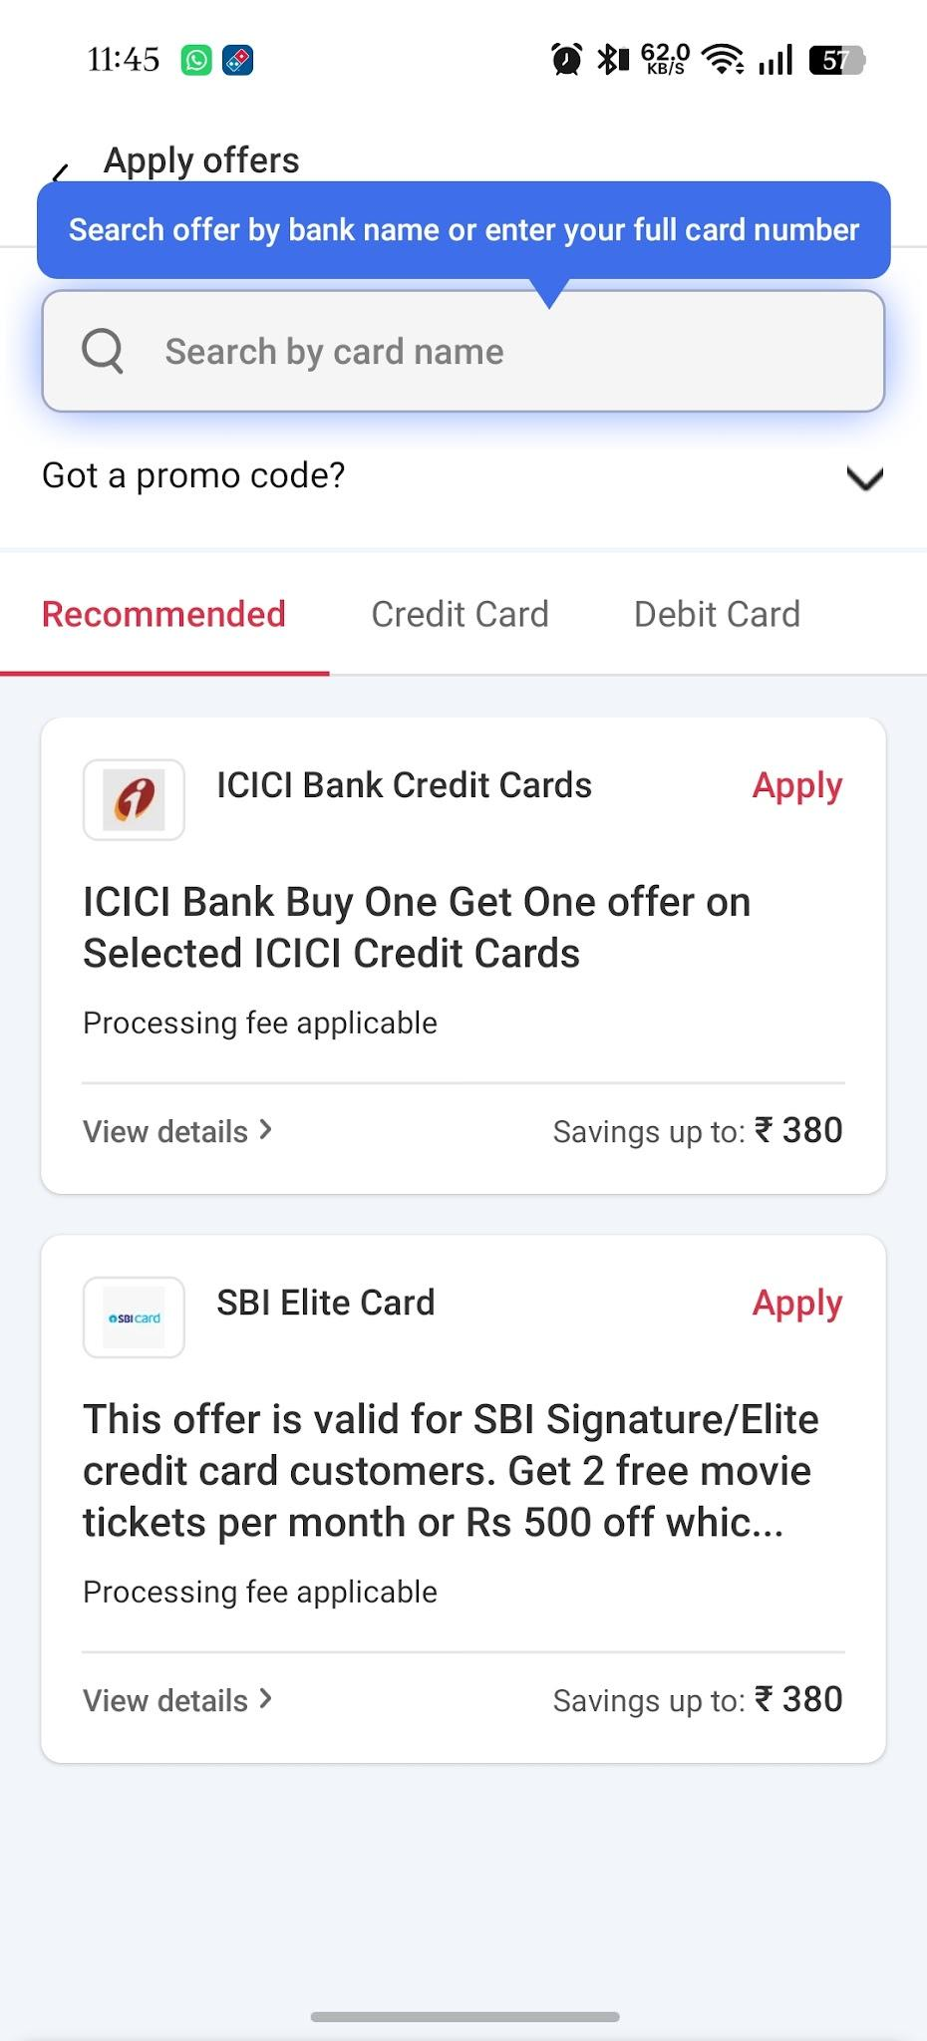

Scenario ID: b12
Scenario | Reject invalid offer/coupon
Test Steps | 1. Open offer/coupon field  2. Enter an invalid code  3. Apply
Test Input | ICIC bank credit card
Expected Results | An appropriate validation/error message is displayed and no invalid discount is applied
Actual Results | Validation message is displayed
Status | Pass
Comments | Negative coupon test

Scenario ID: b13
Scenario | Login during booking
Test Steps | 1. Start a movie booking  2. Continue until login is required  3. Enter valid account details
Test Input | Valid registered account
Expected Results | User is authenticated and returned to the booking flow
Actual Results | User is authenticated and booking flow continues
Status | Pass
Comments | Authentication during booking

Scenario ID: b14
Scenario | Payment with valid details
Test Steps | 1. Complete movie and seat selection  2. Proceed to payment  3. Select a supported payment method  4. Complete payment
Test Input | Valid payment details
Expected Results | Payment is processed and booking confirmation is generated
Actual Results | Booking confirmation is generated after successful payment
Status | Pass
Comments | Positive payment flow

Scenario ID: b15
Scenario | Payment failure handling
Test Steps | 1. Proceed to payment  2. Use a payment method that results in a declined/failed transaction  3. Return to booking flow
Test Input | Declined/failed transaction
Expected Results | Failure message is displayed and the user is not charged for an unsuccessful transaction
Actual Results | Failure message is displayed and booking is not confirmed
Status | Pass
Comments | Negative payment test

Scenario ID: b16
Scenario | Booking confirmation
Test Steps | 1. Complete a successful booking  2. Open booking confirmation
Test Input | Successful booking
Expected Results | Booking ID/details, movie, theatre, showtime and seat information are displayed
Actual Results | Booking confirmation details are displayed
Status | Pass
Comments | Confirmation validation
Screenshots:
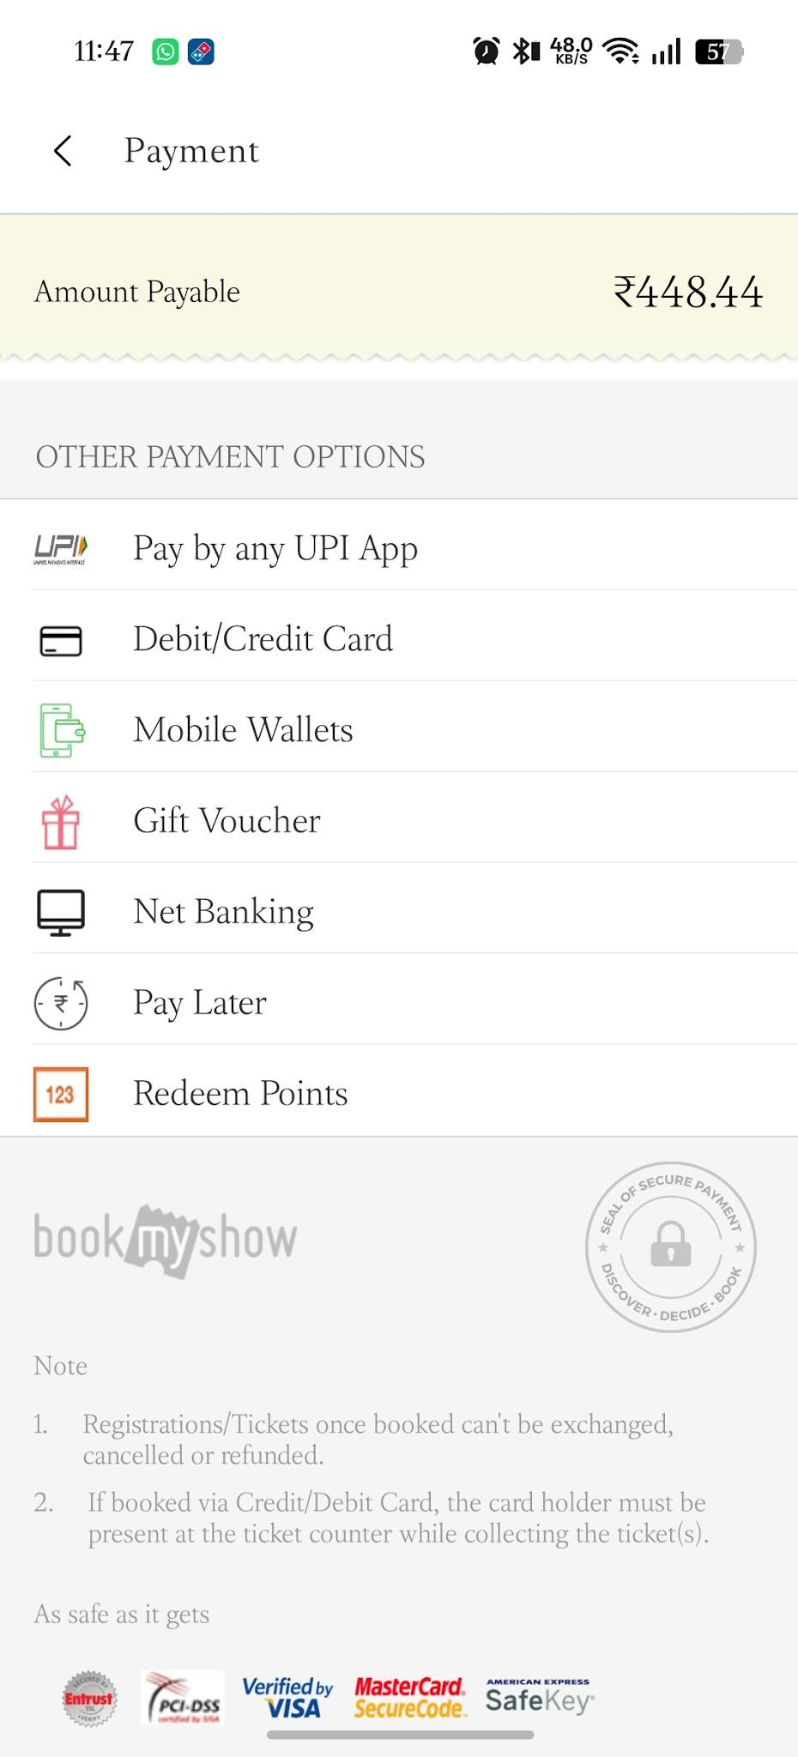

Scenario ID: b17
Scenario | View booking history
Test Steps | 1. Sign in  2. Open profile/account section  3. Open booking history
Test Input | Registered user with booking
Expected Results | Previous booking details are displayed
Actual Results | Previous booking details are displayed
Status | Pass
Comments | Account/history validation

Scenario ID: b18
Scenario | Responsive UI check
Test Steps | 1. Open BookMyShow on desktop browser  2. Resize browser/window  3. Check navigation, movie cards, buttons and booking controls
Test Input | Desktop browser at different widths
Expected Results | UI remains readable and controls remain usable without unintended overlap
Actual Results | UI remains readable and controls remain usable
Status | Pass
Comments | Basic responsive UI check

Scenario ID: b19
Scenario | Empty search validation
Test Steps | 1. Open search  2. Leave search field empty  3. Submit/search
Test Input | Blank search input
Expected Results | System should not perform an invalid search and should retain appropriate search behavior
Actual Results | Blank search does not create an invalid movie result
Status | Pass
Comments | Negative search test

Scenario ID: b20
Scenario | Back navigation during booking
Test Steps | 1. Select movie and showtime  2. Open seat selection  3. Navigate back  4. Check booking state
Test Input | Back navigation
Expected Results | User can navigate back without application crash and the flow remains understandable
Actual Results | Back navigation works without application crash
Status | Pass
Comments | Navigation usability test

Summary of Test Results
Total Test Cases | 20
Passed | 20
Failed | 0
Pass % | 100.00%

Conclusion and Recommendations
Pass Rate: 100.00% — The BookMyShow test scenarios documented in this report cover the primary movie discovery and booking workflow. The recorded results indicate that the tested scenarios completed successfully.
Recommendations
Continue testing with additional real-world negative cases, payment gateway failure cases, session timeout cases, seat-lock/concurrency cases, accessibility checks, and cross-browser/mobile responsiveness checks before considering the workflow fully validated.
Bug Reports
No failed test cases were recorded in this report, so no specific bug report is generated.

